
4/17/2024
Evaluation Report
World Population
Regional Organization
Submitted By:
Elijah Shepherd

Submitted To:
Manager

Introduction
Background: Governments in the East Asia & Pacific region have expressed concerns that some countries in the region are experiencing a decline in populations. Per The World Bank, population decline "can impact a government's commitment to maintain services and infrastructure." As such, governments are inclined to avoid such issues by collecting & analyzing population data in order to determine how much of a threat population decline could be.
Purpose: The project associated with this report used past population data of the East Asia & Pacific region to forecast future population totals of the region as a whole & five other countries in the region. More specifically, the objectives of the analysis were to:
- Identify overall trends in the population data of the East Asia & Pacific region & determine whether there is any (or how much) merit to the concerns regarding declines in populations.
- Prepare a population forecast for the region for five, ten, & fifteen years into the future.
- Identify the five countries with the lowest population growth (or greatest decline), & perform similar forecasts for these five countries individually.
The calculated projections are to be provided to these relevant governments throughout the region to assist them in finding solutions to their concerns regarding their population issues.
The Data: The data used in this project is from two separate datasets: Population numbers for numerous countries & entries from 1960 through 2020, & additional information for numerous entries including their region, income group, & other special notes. As a whole, the data accounts for 265 different entries. There are multiple instances of missing data for some entries, most of which are in the dataset containing additional information on each entry. The missing data did not cause any problems for the purposes of the analyses in this project. The data was provided by The World Bank.
The World Bank states that the "total population is based on the de facto definition of population, which counts all residents regardless of legal status or citizenship. The values shown are midyear estimates." As such, the population values in the dataset that are displayed for each year are midyear estimates as opposed to exact measurements done at the beginning/end of the specified year.

Analysis
The Analysis: The population forecasts were performed separately for the region & five countries of interest. Aside from some small differences, the same general method was used for both cases. Essentially, the past population data for each country/region was analyzed to determine their population growth rates over time. These growth rates & their trends were used to forecast future growth rate values which were then used to calculate corresponding future population values. Multiple methods & strategies could be used to calculate these projections, but since the desired projections were specified to be in five-year spans, it seemed most ideal to use the past data based on five-year spans as well. As such, the average growth rate of each country/region was calculated on a five-year basis (1961-1965, 1966-1970, & so on). These five-year averages were used to determine & forecast future growth rates.
Since population is usually a smooth, continuous variable (population is unlikely to change drastically over short periods of time such as a year), it is important to take recent trends into account when projecting future population numbers. To accomplish this, the concept of weighted averages was used. Weighted averages apply numerical weights to certain values based on which values are more/less important. In this case, more recent data is more important, so more recent growth rate values were assigned a larger weight. To calculate a weighted average, the value is multiplied by the corresponding weight. These calculations were performed in Microsoft Excel.
These weighted averages helped in determining future growth rates that were used to forecast population values for the region & each country. More in depth discussion is in the project itself.
Additionally, upper & lower projections were calculated to determine the most likely range in which the future population could be within. This was done to provide more contextual information for the relevant governments. To calculate these lower & upper projections, past growth rates were analyzed, & then reasonable future growth rates were assigned & used to calculate future population numbers. In the figure below, there are multiple plots superposed onto the same figure to illustrate the different projections. The vertical, dashed line differentiates between the historical data (1960-2020) & the population projections (2021-2035). The blue line after 2020 defines the main projections of the population, whereas the green & orange lines represent the upper & lower projections respectively.
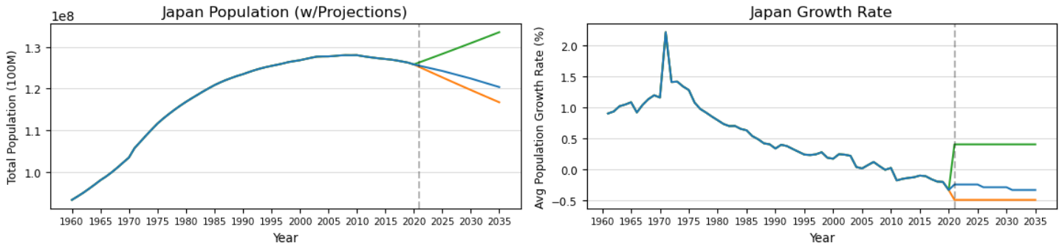
Differences between calculating projections for the region & the five countries arose because the calculations in the Excel spreadsheet weren't always as consistent with the trends seen in the past population data across each country/region. Handling these differences & inconsistencies was the greatest challenge in this project because it was important to utilize the results of the analysis, but it was also important to use & implement them consistently across each of the six cases. If there was a clear overall & consistent trend, it was easier to simply project future growth rates that followed a similar trend, but if there was not a clear trend, it was more appropriate to use an overall average calculated in the Excel spreadsheet. With some countries, the growth rate in the projections changed but it did not for others. Effectively, the growth rates were chosen to optimize the combination of accuracy & representativeness. For example, in Japan's projections, which can be seen in the figure directly above, using a growth rate larger than any rate observed from the data would contradict the clear downward trend that is seen since about 1970. Additional in depth discussion regarding how the projections of each country were handled is in the project.
Multiple python modules were used in the project including matplotlib, seaborn, plotly.express, & others. One function that was used on multiple occasions was the plotly.express choropleth. A choropleth is an interactive map that can display different areas of the Earth including countries, provinces, states, state countries, & more. Choropleths can also be manipulated to display different colors for different areas depending on another quantity in the data. A plotly.express choropleth can also be made as an animated plot that changes depending on another quantity. In this project, choropleths were used to display different countries, their populations, & how their populations changed over time.
The forecasted population data for the region & each country was summarized & figures were made to illustrate these numbers. These details are discussed in the Conclusions section below, but more discussion is in the project.

Results
The data for the East Asia & Pacific region accounted for 37 different countries. From 1960 to 2020, the total regional population ranged from approximately 1.0 billion to 2.4 billion. The two maps (choropleths) below highlight most of the countries that are in this region (some countries aren't visible due to their small physical size). The first map indicates a country's population in 1960, & the second map indicates a country's population in 2020. The change in color of each country illustrates how the population changed over time.
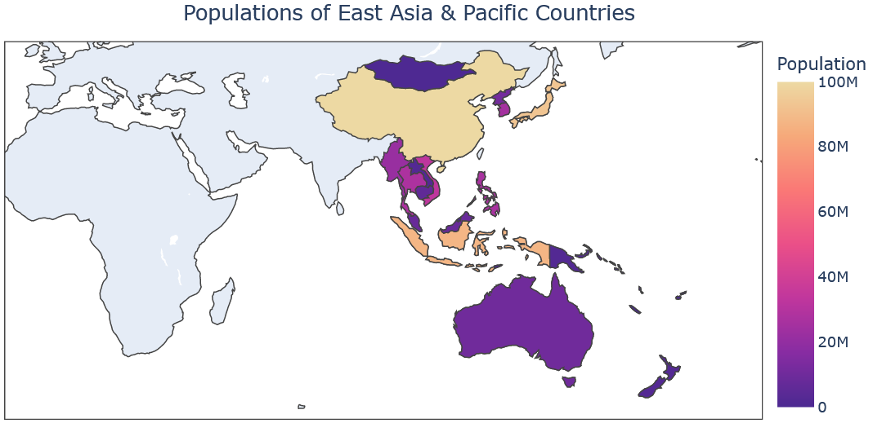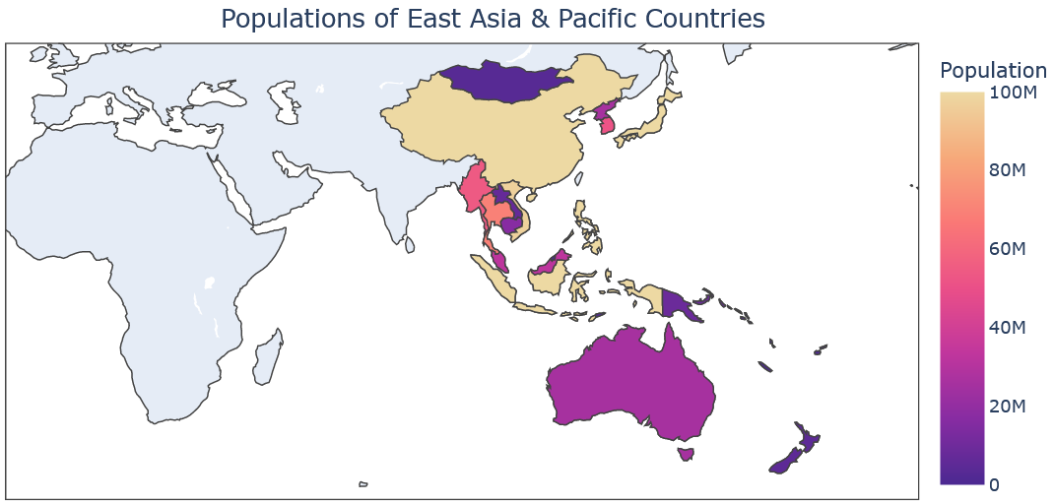
The region did not experience an overall decline in population from 1960 to 2020, nor a decline across any span of time. In fact, the total regional population more than doubled. Additionally, no countries experienced an overall decline in population from 1960 to 2020. On the other hand, there were at least 100 instances in which some countries experienced a decline in population over the course of a year or longer. Therefore, there is some data to suggest that declines in population throughout the region are taking place.
Though the population never declined from 1960 to 2020, the East Asia & Pacific region did experience a considerable decrease in the growth rate of the population. The two figures below illustrate that the population's growth rate declined by about 2.0% from 1962 to 2020. Since 1970, the growth rate only increased ten times. Apart from 1961, the growth rate in 2020 was as low as it ever was. Even though the decline of the regional growth rate slowed from about 2003-2017, it decreased steeply again from around 2017-2020. As such, there is enough evidence to suggest that this growth rate will continue to descend closer to zero & potentially even into the negatives. The projections of the regional population explored this further.
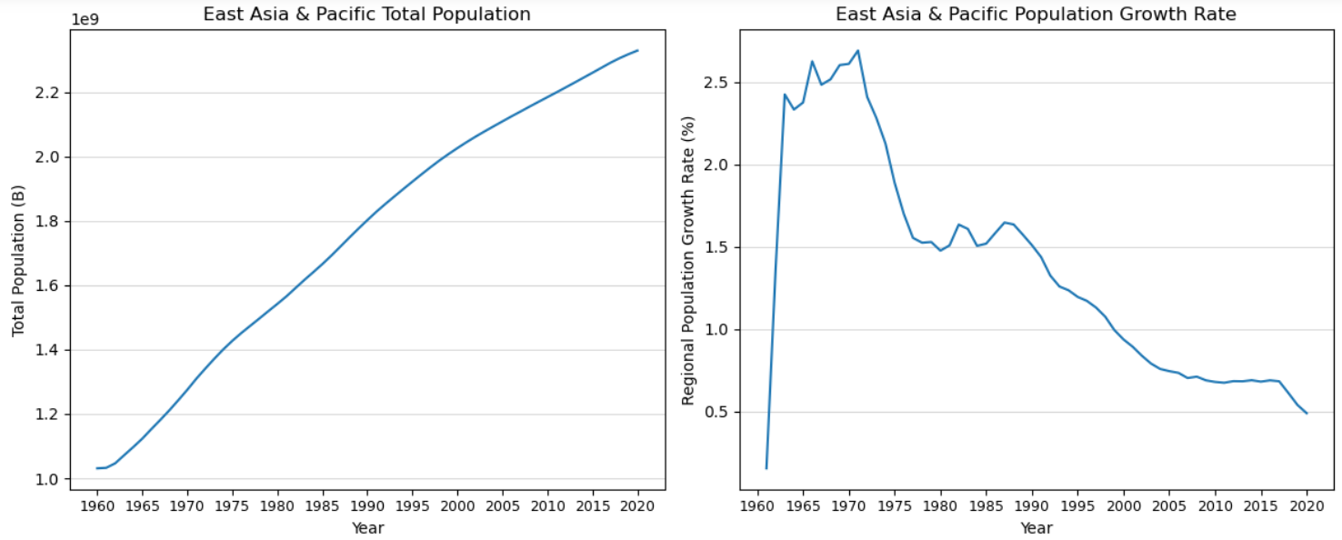
In the two figures below, the vertical axis of the right-hand plot displaying the growth rate is described as the "Average" growth rate because the projections from 2021-2035 used three five-year averages to calculate the population projections.
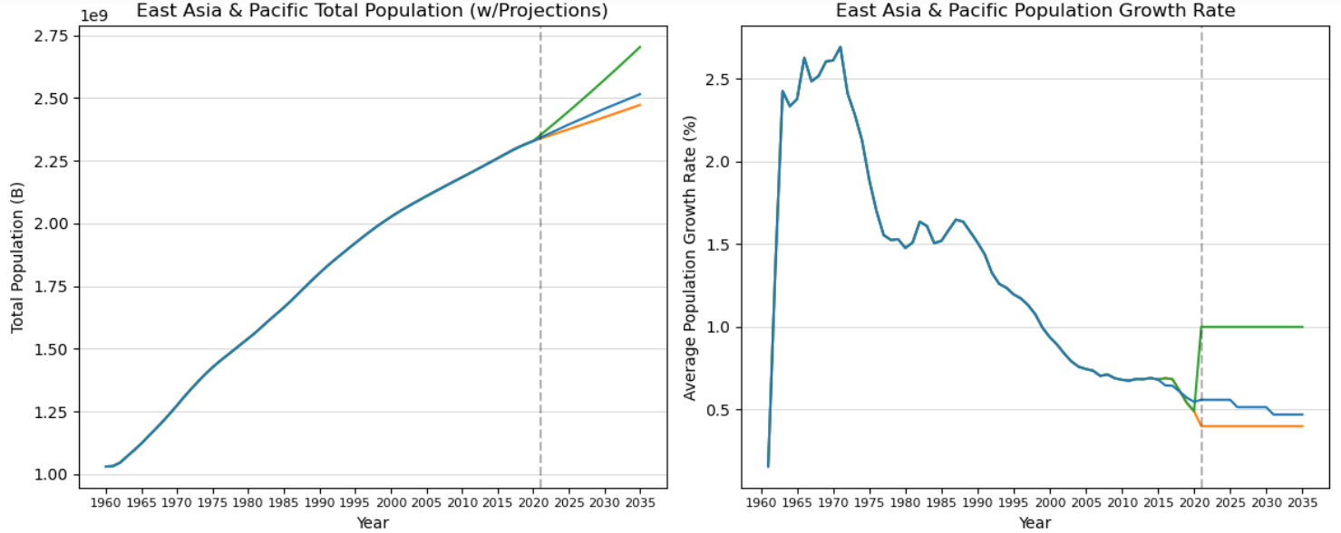
The results of the projections of the regional population include:
- In 2025, the total population will be approximately 2.394 billion with a growth rate of approximately 0.560%. Most likely, the population could be as low as 2.375 billion & as high as 2.447 billion.
- In 2030, the total population will be approximately 2.457 billion with a growth rate of approximately 0.515%. Most likely, the population could be as low as 2.423 billion & as high as 2.572 billion.
- In 2035, the total population will be approximately 2.515 billion with a growth rate of approximately 0.471%. Most likely, the population could be as low as 2.472 billion & as high as 2.703 billion.
These projections illustrate an overall decline in the population growth rate of the East Asia & Pacific region. The projected growth rates are lower than any previous growth rates from 1962-2020. If the projected growth rates continue to decrease at this rate, it will become negative sometime around 2090, at which point the total regional population will be approximately 2.8 billion.
After determining that concerns regarding a decline in population growth in the East Asia & Pacific region are credible, additional analysis revealed similar results regarding some countries in the region. After calculating the 60-year growth rate of each country in the region, the five countries with the smallest growth rates (in increasing order) were determined to be Japan, Tonga, Samoa, Palau, & South Korea. They had total population growth rates of approximately 35.0%, 71.7%, 82.7%, 85.2%, & 107.0% respectively. Of the 105 instances in which a country experienced a decline in population from 1960-2020, these five countries accounted for 30. For reference, the total population growth rate from 1960 to 2020 of the entire East Asia & Pacific region was about 125.9%. Also, the average total population growth rate by country in the region was about 208.0%. Additionally, China—the most populous country in the region from 1960-2020—had the sixth smallest total population growth rate (~110.2%) in the region.
On another note, these countries have significantly different total populations. Japan & South Korea had total population changes between 25 to 35 million, Tonga & Samoa had total population changes between 40,000-90,000, & Palau had a total population change of about 8,300.
The two maps below illustrate how the populations of these five countries changed over time. Unfortunately, Tonga, Samoa, & Palau were too small in physical size to show up on the choropleths. For reference, Tonga is a kingdom of more than 170 South Pacific islands which are east of Australia. Samoa is an island country consisting of several islands which are east of Australia & northeast of Tonga. Palau is an archipelago of over 500 islands in the western Pacific Ocean which are east of the Philippines & north of Indonesia.
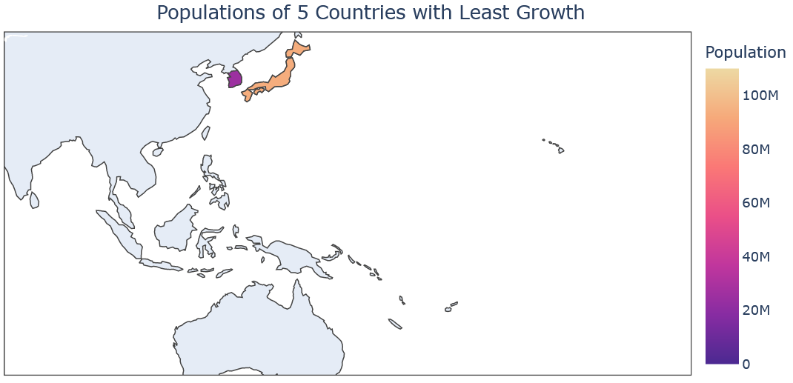
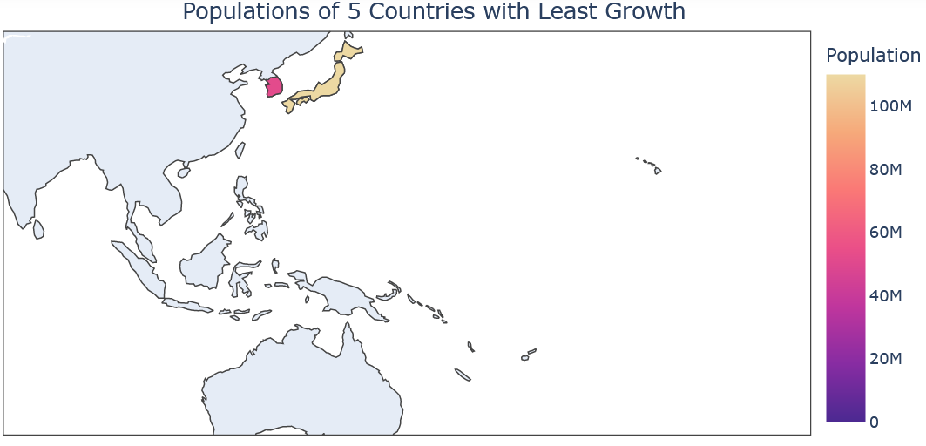
As was the case for the total population of the East Asia & Pacific region, none of these five countries had a smaller population in 2020 than in 1960. The overall trend of most of these countries' population growth rates were also similar to that of the region in that they decreased considerably over the 60 years of data. In fact, each of the five countries had smaller growth rates in 2020 than in 1960. Japan, Tonga, & Palau experienced multiple years of a negative population growth rate, & most of these instances occurred recently (2005-2020); however, Japan was the only country of the five with a negative growth rate in the most recent data (from about 2017-2020). The population data from these five countries is more indicative than that of the region in that population growth is declining, & that the concern of population decline is indeed becoming more relevant as time has gone on.
Additionally, it is worth pointing out how the two countries with significantly larger populations have clearer overall & smoother population curves (Japan & South Korea) than the three smaller countries (Tonga, Samoa, Palau). Japan & South Korea also have the smallest population growth rates of these five countries at the end of the data range.
Of these five countries, Japan's population has the clearest trend & the most concerning data. Although Japan had the largest population among these five countries, they also had the smallest total population growth rate of any country in the region. From the figures below, Japan had the least varying growth rate of the five countries over the six decades & was the only country with a negative growth rate going into 2021. Since a large upward spike in growth rate in the early 1970s, Japan's growth rate steadily decreased & has been negative since 2011. Japan's most recent growth rate is as low as it has ever been, & their average population growth rate (~0.503%) is larger than any yearly growth rate Japan has seen since about 1985. Japan had 11 instances of yearly population decline, all of which were from 2009-2020.
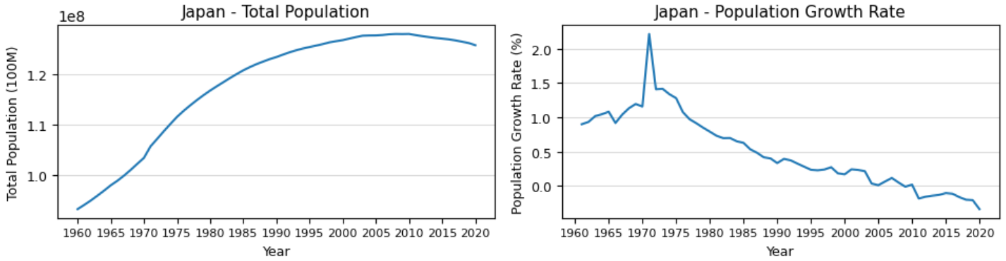

The results of the projections of Japan's population include:
- In 2025, the total population will be approximately 124.27 million with a growth rate of approximately -0.250%. Most likely, the population could be as low as 122.72 million & as high as 128.37 million.
- In 2030, the total population will be approximately 122.45 million with a growth rate of approximately -0.295%. Most likely, the population could be as low as 119.68 million & as high as 130.96 million.
- In 2035, the total population will be approximately 120.38 million with a growth rate of approximately -0.339%. Most likely, the population could be as low as 116.72 million & as high as 133.60 million.
Japanese officials are accurate regarding their concerns of a declining population which is not showing any signs of stopping. The lower limit of the population projections is helpful in accounting for the possibility that the population decline worsens beyond what is expected by using growth rates smaller than what is forecasted based on the trends seen in the data.
Trends in Tonga's population are less apparent than for Japan. Tonga's growth rate experienced a significant decline early in the data & neared zero, but then slowly increased for about two-and-a-half decades before suddenly descending below zero for a few years; however, the growth rate re-ascended back above zero just as quickly & was on a relative high by 2020. Of these five countries, Tonga had the largest growth rate at any time & some of the most variance overall (about five percent). From around 1960-1983, there is a clear downward trend in Tonga's growth rate, yet it remained positive. From about 1984-2020 there is an overall, less-steep-but-upward trend in the growth rate apart from the sudden downward spike at around 2010. Tonga's average population growth rate is about 0.911%, which, since 1979, was only eclipsed in the last three years of the data.
Although Tonga's growth rate was only negative for five years, those five years came in the last ten years of the data. As a result, the weighted averages took these recent data into greater consideration which ultimately caused the forecasted potential growth rates to span a wide range in the projections (nearly three percent). In these projections for Tonga's population, there is room for the overall upward trend since the mid 80s to continue & for another steep downward spike to occur. Tonga had five instances of yearly population decline, which occurred from 2011-2015.
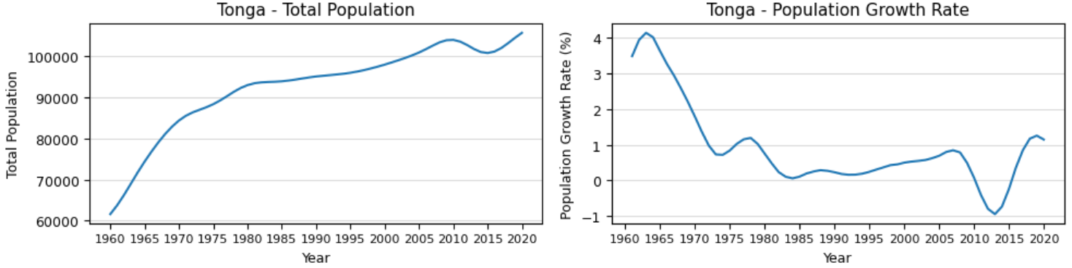
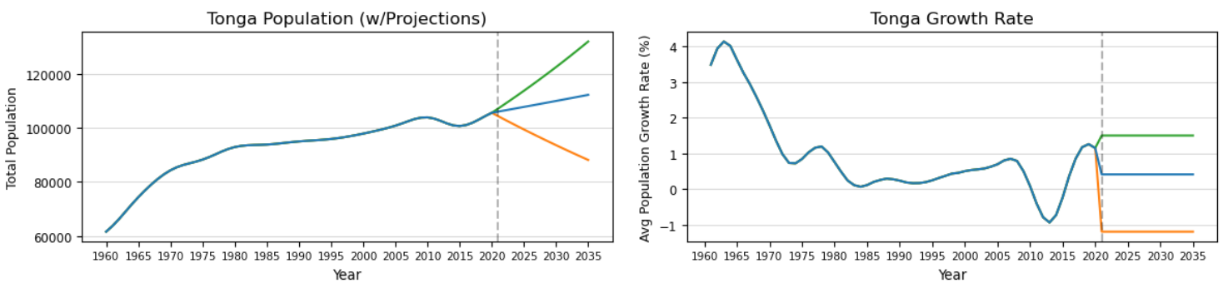
The results of the projections of Tonga's population include:
- In 2025, the total population will be approximately 107,870 with a growth rate of approximately 0.408%. Most likely, the population could be as low as 99,506 & as high as 113,870.
- In 2030, the total population will be approximately 110,090 with a growth rate of approximately 0.408%. Most likely, the population could be as low as 93,676 & as high as 122,670.
- In 2035, the total population will be approximately 112,360 with a growth rate of approximately 0.408%. Most likely, the population could be as low as 88,189 & as high as 132,150.
Tongan officials should be weary of the prospect population decline because it has happened recently. On the other hand, the overall upward trend in population growth rate from the early 80s to 2020 could help avoid any population decline in the future should this upward trend continue. Since sudden downward trends have proven to happen, Tongan officials should remain cautious.
Samoa's population data is quite similar to Tonga's only it is just a bit smoother. Samoa also had a considerable decline in the growth rate from about 1960-1975, but the growth rate remained relatively stable for the rest of the time in the data. Although the growth rate began above three percent, it quickly descended below one percent by the mid 70s & has not reached one percent since (Samoa's average growth rate is 1.013%). Samoa is one of two countries among these five that never had a yearly decline in population. In fact, Samoa's growth rate stayed the furthest from zero percent—Samoa's minimum annual growth rate was about 0.25% (1987 & 1988). On a more recent basis, the growth rate declined from 2012-2018 but increased in the last three years of the data.
Since Samoa's population growth rate never fell below zero, the lower limit of the projections used a positive growth rate. Also, given that Samoa's growth rate hadn't reached one percent since the mid 70s, the upper limit of the projections used a growth rate just above one percent. Samoa never experienced any yearly population decline from 1960-2020.
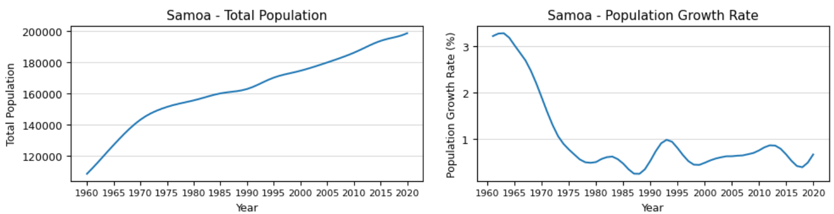
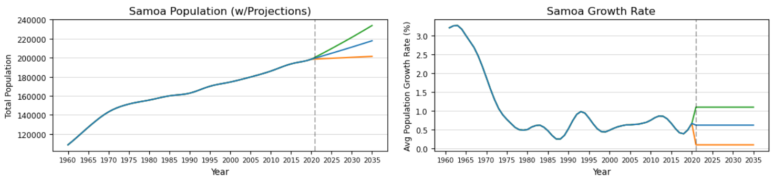
The results of the projections of Samoa's population include:
- In 2025, the total population will be approximately 204,670 with a growth rate of approximately 0.623%. Most likely, the population could be as low as 199,405 & as high as 209,570.
- In 2030, the total population will be approximately 211,120 with a growth rate of approximately 0.623%. Most likely, the population could be as low as 200,400 & as high as 221,350.
- In 2035, the total population will be approximately 217,770 with a growth rate of approximately 0.623%. Most likely, the population could be as low as 201,410 & as high as 233,790.
Given the stability of Samoa's growth rate over the past four decades or so & the lack of any annual decline in population, local officials could take some solace that they have so far avoided population decline & may continue to do so. On the other hand, the overall decline of the growth rate since 1960 could suggest that a negative growth rate may happen should a sudden downturn in the population growth rate occur.
Palau had the most varying & therefore the most unpredictable population data of these five countries. The growth rate began at its maximum in 1960 at just under three percent, but by the late 70s it had descended to nearly negative two percent. It then jumped back up to around 2.8% in the early 80s & did not fall below two percent again until 1999. Unfortunately, the next decline of Palau's growth rate appears more terminal in that it descended further than the previous decline (the rate fell below negative two percent in 2008 & 2009), & it took longer to reascend to zero percent. Additionally, it did not eclipse 0.60% & stabilized at about 0.50% in the last couple of years. So overall, the growth rate declined by about two percent, but it spanned a range of about five percent.
Given the sweeping & sudden changes in the growth rate of Palau's population over the 60 years, the projections used the widest span of growth rates of any of the five countries. As seen in the figures, Palau could easily have a sudden & steep upward or downward surge in growth rate at almost any time. Since the sizable negative growth rate was more recent than any sizable positive growth rate, the lower limit of the projections used a relatively larger negative growth rate than the positive growth rate that the upper limit used. Additionally, Palau's average growth rate of 1.044% was last eclipsed in 2002. Ultimately, both the lower & upper limit projections had magnitudes of over two percent. Palau had 14 instances of yearly population decline (1976-1980 & 2005-2013).
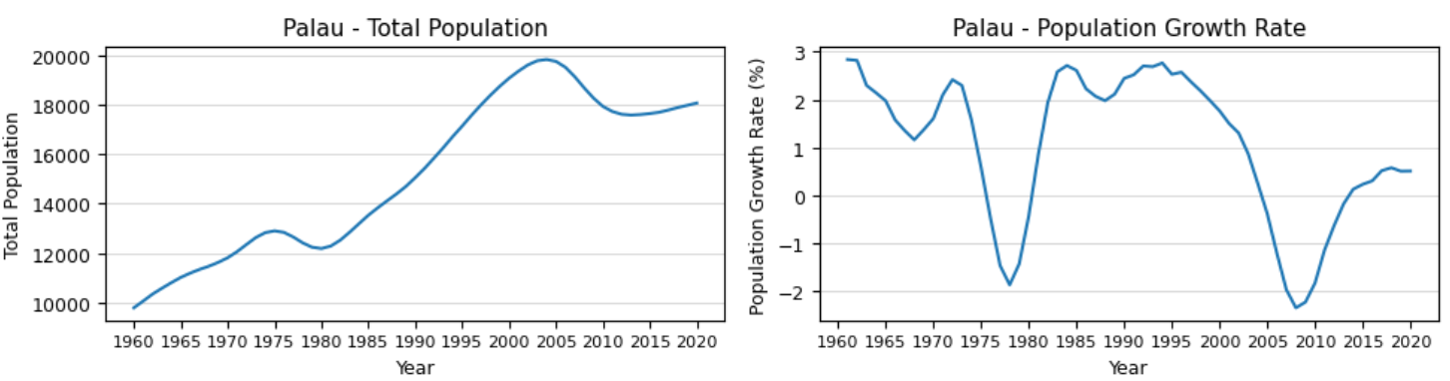
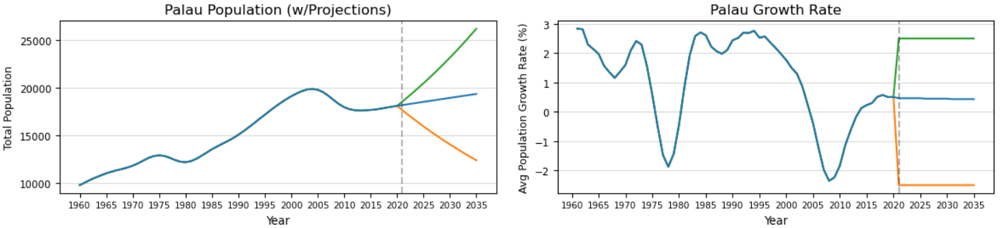
The results of the projections of Palau's population include:
- In 2025, the total population will be approximately 18,515 with a growth rate of approximately 0.463%. Most likely, the population could be as low as 15,941 & as high as 20,469.
- In 2030, the total population will be approximately 18,933 with a growth rate of approximately 0.448%. Most likely, the population could be as low as 14,045 & as high as 23,160.
- In 2035, the total population will be approximately 19,346 with a growth rate of approximately 0.437%. Most likely, the population could be as low as 12,376 & as high as 26,202.
Since 2002, Palau's annual growth rate has been negative & positive an equal number of times (9). This recent data is indicative that Palau could continue to experience a population decline in the near future. Therefore, local officials should be weary of future sudden downturns in the population growth rate that could result in considerable population decline.
Of these five countries, South Korea's population data is most similar to Japan's, with the largest difference being that South Korea never experienced a decline in population over any time span. South Korea's population data is more linear & smoother than any of the five countries. As a result, trends are easier to spot, & as the case was for Japan, South Korea faces similar results regarding concerns of population decline. Although South Korea did not ever experience a yearly population decline, the country's growth rate is as low as it ever was in the data. South Korea's average growth rate of 1.223% has not been seen since the early 1980s.
Because of the clear & consistent decline in the growth rate, the upper limit of the projections used a growth rate that was below South Korea's average. The lower limit used a non-negative growth rate because South Korea has yet to experience a decline in population, but the rate was smaller than any rate seen from the data. South Korea never experienced any yearly population decline from 1960-2020.
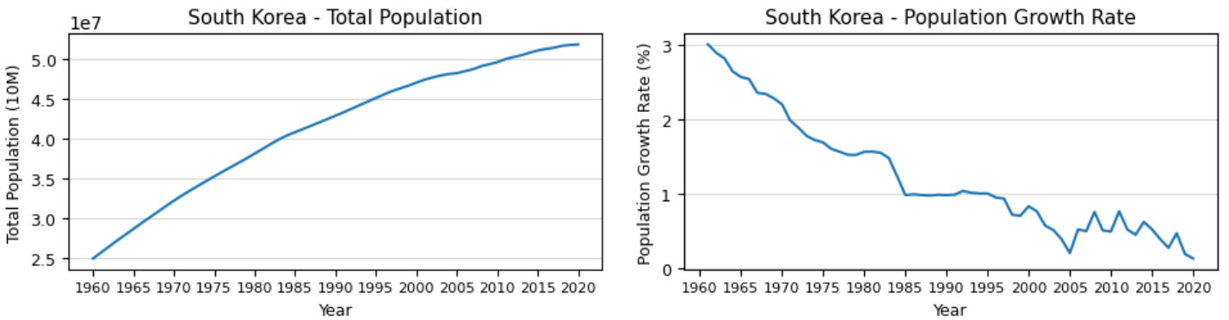
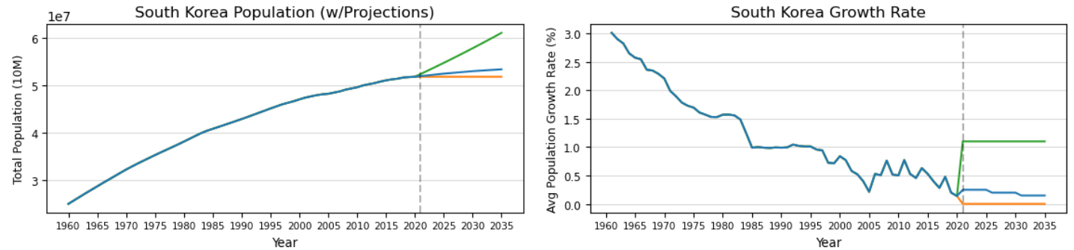
The results of the projections of South Korea's population include:
- In 2025, the total population will be approximately 52.426 million with a growth rate of approximately 0.248%. Most likely, the population could be as low as 51.781 million & as high as 54.692 million.
- In 2030, the total population will be approximately 52.947 million with a growth rate of approximately 0.198%. Most likely, the population could be as low as 51.781 million & as high as 57.767 million.
- In 2035, the total population will be approximately 53.338 million with a growth rate of approximately 0.147%. Most likely, the population could be as low as 51.781 million & as high as 61.015 million.
South Korea's population growth rate, while it relates to Japan's in many ways, is about ten years behind Japan's. This gives South Korean officials an opportunity to avoid the same population problems that Japan encountered in the last ten years—population decline; however, it is important that actions are taken soon. Based on recent & overall trends of the data, South Korea's population growth rate could become negative as early as the 2050s.

Conclusions
Recall the goals of the project. The primary objectives included:
- Identify overall trends in the population data of the East Asia & Pacific region & determine whether there is any (or how much) merit to the concerns regarding a decline in populations.
- Prepare a population forecast for the region for five, ten, & fifteen years into the future.
- Identify the five countries with the lowest population growth (or greatest decline), & perform similar forecasts for these five countries individually.
The population of the East Asia & Pacific region increased yearly from 1960-2020; however, the rate of population growth decreased considerably from 1961-2020 (from about 2.5 to 0.5 percent). Regarding concerns of declines in population, there is not an imminent concern of any population decline in the region. With that being said, there is a looming concern that the region's population growth rate could continue an evident downward trend closer to zero & become negative in the next few decades, ultimately resulting in population decline. Based on the projections done in the project, the regional growth rate will become negative around 2090. Although this trend is concerning, there is considerable time for regional officials to address the falling population growth rate before any population decline takes place.
Regarding countries in the region, concerns of population decline are more prevalent because such declines have taken place in the data. The five countries in the region with the lowest total population growth were Japan, Tonga, Samoa, Palau, & South Korea. These five countries exhibited vastly different population totals during the 60 years of data. Japan, the most populous country of this group, is the country with the clearest trend in the population data, which clearly illustrates & garners merit to the concerns of population decline. Of the main projections performed for each country, they all had growth rates which were smaller than one percent. In each case, the growth rates in these projections were smaller than the growth rate seen at the beginning of the data. While only Japan's main projections from 2021-2035 displayed any population decline, the projections of the other four countries forecast declining growth rates that may eventually become negative & cause population decline. As such, officials of these five countries, especially of Japan, should be weary of declining growth rates that could result in future population decline.
There is additional information in the datasets which could provide more context in the analyses done in this report. Specifically, the 'income group' parameter labeled each country in the data with one of the following values: low, lower middle, upper middle, or high income. Unfortunately, neither the dataset nor the source defines these values, which makes it difficult to understand exactly what these values mean. The main information that can be gleaned is that high-income populations have greater incomes than upper-middle-income populations & so on.
Analyses of this parameter relevant to this report could provide additional information regarding population decline. For example, it's possible that some countries with a predominantly high-income population may have experienced a stable growth in population, but other countries with a predominantly lower-middle-income population may have experienced a declining or negative growth in population. Such trends could reveal a potential correlation or relationship between population growth & income group. This information could be useful in projecting future population values & finding solutions as to how to deal with any potential significant changes in population.
Though this report is only relevant for the East Asia & Pacific region, the dataset allows for similar analyses of other regions & countries throughout the world, & the world as a whole. In doing so, the findings regarding population decline could be compared between the region of interest (East Asia & Pacific) & the rest of the world to understand if the population concerns evaluated in this report are specific to this region or more widespread. Furthermore, such analyses could help understand how concerns over population decline could be solved in the East Asia & Pacific region by analyzing how other regions have averted such problems (if there are any such regions). Additionally, if the five countries in the region with the greatest growth were analyzed further, any findings could help government officials of regions & countries with smaller amounts of growth & any problems they have regarding population decline.
Population forecasts could easily be continued into the future as more data is collected over time. If the method of weighted averages would continue to be utilized, the weights of each five-year span would likely need to be changed as more recent data would be more relevant than previous data.

Additional Notes
These links contain the source & license of the dataset. The python notebook & Excel spreadsheet files are contained & accessible in the folder also containing this Word document. The python notebook is an HTMl file titled "Python Notebook – World Population Data." The Excel spreadsheet is titled "weighted avgs."
In the python notebook, the relevant analysis is in the "Analysis IV" section, which is about 60% of the way into the notebook.

